{%p **if** ucm_cloud %}

## Solution Overview UCM Cloud

The Cisco Unified Communications Manager Cloud (Cisco UCM Cloud) is part of Cisco’s Cloud Calling portfolio powered by Cisco’s collaboration technology – Cisco Unified Communications Manager (Cisco UCM). The service offers voice, video, messaging, meeting, and mobility solutions with the features and benefits of Cisco IP phones, mobile devices, and desktop clients.

Cisco UCM Cloud is part of the Cisco Collaboration Flex Plan set of offers, which includes key Cisco commercial and administrative tools to facilitate the go-to-market and common subscription plans, including Webex Teams and Webex Meetings.

Cisco UCM Cloud is hosted and operated by Cisco in North America, Europe, the Asia Pacific region, and Japan.

{%p endif %}

{%p **if** ucm_cloud_g %}

## Solution Overview UCM Cloud for Government

Thanks to the widespread adoption of mobile devices, government agencies can now empower their teams with the latest in voice and real-time video and information-sharing technologies. This singular trend is helping governments improve response times, increase information sharing, and create better outcomes for employees and citizens alike.

However, providing proven and reliable collaboration tools with advanced levels of security required by the U.S. government can be a challenge. Cisco Unified Communications Manager (UCM) Cloud for Government unites Cisco’s industry-leading collaboration services (voice, video, instant messaging, presence, mobility, and conferencing) from the Cisco cloud, with built-in U.S. government-level security to give agencies the power to collaborate securely with anyone, anywhere.

With Cisco UCM Cloud for Government, your team benefits from a “one service, one experience for everyone” solution that is Federal Risk and Authorization Management Program (FedRAMP) authorized to better protect your data and privacy and empowering {{ customer }} with:

● A FedRAMP-authorized collaboration solution

● Simple, cloud-based service

● Voice, real-time video, and information sharing

● End-to-end encryption

{%p endif %}

Cisco has partnered with Iron Bow to offer UCM Cloud to customers desiring a secure cloud-based Voice over IP (VoIP) service. Because of its as-a-service nature, UCM Cloud reduces complexity for IT teams and end users. With UCM Cloud, {{ customer }} can shift from a Capital Expenditures (CapEx) model to an Operating Expenses (OpEx) financial model by paying for only what they need. The solution can be combined with WebEx Meetings which offers integrated audio, video, and content sharing with highly secure web meetings from the Cisco WebEx cloud.

UCM Cloud supports a broad portfolio of voice and video devices, from IP phones to mobile and desktop applications. This gives each user the right tools for their job; from administrators and thought leaders, to production and field personnel and beyond. UCM Cloud supports the following endpoints:

Cisco 7800/8000 Series IP Phones

Cisco Jabber

Cisco WebEx Teams

Cisco DX Series

Cisco WebEx Room Series

Cisco Telepresence SX Series

Cisco Telepresence MX Series

Standards based 3rd party endpoints

Iron Bow is a Cisco Gold Certified Partner with Advanced Specializations in Collaboration, Data Center, Enterprise Networks and Security Architectures. Iron Bow also holds Masters Certifications in Collaboration, Cloud Builder, Security and Cloud and Managed Services. With over 50 Cisco Certified Engineers and a partnership with Cisco spanning over a decade, we are able to offer our clients services ranging from consultation, planning, design, implementation, operation and optimization of IP Network Infrastructures.

Included in our scope is the installation of the UCM service and the implementation and setup of the cloud-based Cisco servers. This includes the premise-based components of the solution to be installed at the {{ customer }} – such as the on-premises router for PSTN connectivity and Cisco Expressway for video services. Iron Bow will deliver the UCM Cloud solution to the {{ customer }} using a cloud-based Cisco Communications Manager (publisher/subscriber), Unity Connection (primary/secondary), Emergency Responder (primary/secondary), IM and Presence (primary/secondary), and Expressway Control/Edge.

Iron Bow is proposing WebEx for {{ customer }} conferencing needs. WebEx is an industry leading conferencing and collaboration tool used each month by more than 130 million professionals who rely on WebEx to connect, collaborate and move projects forward faster. Teams can work with anyone via web browser, mobile, or audio/video device. WebEx Meetings offers integrated audio, video, and content sharing with highly secure web meetings from the Cisco WebEx cloud.

## 5.2 Technical Architecture

***Figure 1*** depicts the high-level overall solution architecture consisting of the proposed UCM Cloud and on premise items. The UCM Cloud cluster will be properly sized to accommodate {{ customer }} end user count today as well as have the capacity to grow into the future. By taking advantage of Collaboration Edge technologies like Mobile and Remote Access (MRA), satellite locations, home users, and people on the go can leverage their existing internet connection to securely connect to the UCM Cloud infrastructure.

Figure 1: UCM Cloud High Level Architecture

***Figure 2*** depicts a high-level overview on the network connectivity options to UCM Cloud. UCM Cloud allows for multiple connection options including MPLS, SD-WAN, Equinix ECX and VPN.

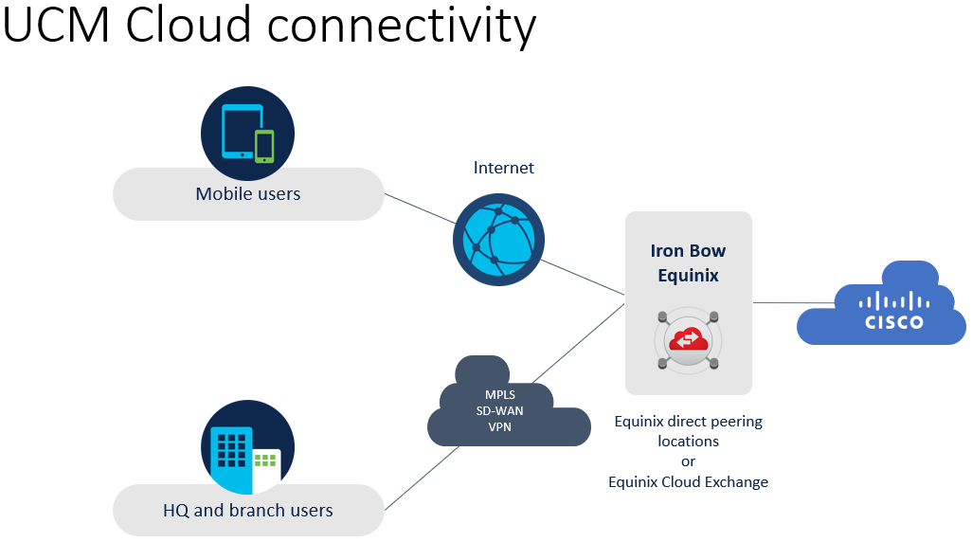

Figure 2: UCM Cloud High Level Network Connectivity

**UCM Cloud Implementation:** The UCM Cloud solution consists of Cisco Unified Communications Manager, Unity Connection, IM and Presence, Emergency Responder and Expressway. All systems will be running version 12.x software. The applications will be hosted on Cisco Unified Computing System (UCS) servers, using VMware’s ESXi hypervisor.

UCM Cloud is powered by Cisco’s Unified Communications Manager (UCM) collaboration technology and this next-generation platform will enable the {{ customer }} staff to make meaningful connections via voice and video calling, messaging, and mobility—anytime, anywhere, and on any device. It does this with Cisco's integrated collaboration infrastructure for voice and video calling, messaging, and mobility. It also provides reliable, secure, scalable, and manageable call control and session management. Specific features of the platform include:

* **Unified Communications**: UCM Cloud will enable the {{ customer }} to consolidate and integrate its existing communications infrastructure, enable its community to communicate simply using IP telephony, high-definition video, unified messaging, and Instant Message and Presence.
* **Enhanced Mobility**: UCM Cloud will enable the {{ customer }} to transform its work and learning spaces so that staff can do their work wherever they are or need to be.
* **Scalable**: UCM Cloud is a solution that will enable to {{ customer }} to scale to meet growth, so that as the needs of {{ customer }} change and technological innovation progress, {{ customer }} can keep pace easily and cost effectively.
* **Open and Interoperable**: UCM Cloud supports industry standards, a wide range of gateways, and the broadest ecosystem of third-party integrations and solutions in the industry. This flexibility will enable the {{ customer }} to avoid vendor lock-in and ensure that your community enjoys rich collaboration with anyone, anywhere.
* **Secure and Compliant**: UCM Cloud supports the latest authentication, encryption, and communication protocols. It complies with key industry certifications and secures data and communications.
* **UCM High Availably:** The UCM Cloud service will be “Operational” as defined in the Service Level Agreement (SLA) section of Addendum 1- UCM Cloud - Service Description - v.1.1.docx

{%p **if** ucm %}

**Unified Communications Manager (UCM)**

Cisco Unified Communications Manager (UCM) is the core of the UCM Cloud offering. It delivers people-centric user and administrative experiences while supporting the full range of collaboration services including, video, voice, instant messaging and presence, messaging, and mobility on Cisco as well as third-party devices. UCM is the industry leader in enterprise call and session management platforms, with more than 300,000 customers worldwide, and more than 120 million Cisco IP phones and soft clients deployed.

UCM Cloud will further extend Cisco UCM’s leadership through features that enrich user experiences, simplify administration workloads, enhance security while providing pathways for customers to migrate to cloud collaboration.

This is ideal for customers wanting to move infrastructure to the cloud, but who need highly customizable solutions, retention of admin control over applications, and maintaining familiar admin experiences.

{%p endif %}

{%p if endpoints %}

**Endpoints**

Iron Bow’s proposed Cisco solution consists of three different phones models: 1) the Cisco IP Phone 8851, 2) the Cisco IP phone 7841, and 3) the Cisco IP Conference Phone 8832. The first two models include both multi-line capability and rollup capabilities, as well as the ability to answer up to four distinct numbers.

{%p if cisco_8851 %}

The Cisco IP Phone 8851 is ideal for Executives, Management and Knowledge works, personnel who require a business-class collaboration endpoint. The 8851 offers five programmable line keys and five programmable soft keys. You can configure the 10 keys to support either multiple directory numbers (lines) or calling features such as speed dial. Fixed-function keys give you one-touch access to applications, messaging, and directories, as well as often-used calling features such as hold/resume, transfer, and conference.

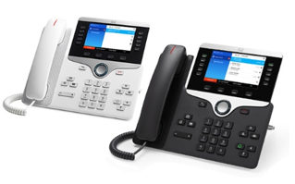

Other key features of the **Cisco IP Phone 8851** include the following:

* The ability to boost productivity by handling multiple calls for each directory number using the multicall-per-line feature.
* A user-friendly display that includes a widescreen (5-inch), high-resolution (800 x 480) Video Graphics Array (VGA) backlit color display.
* The ability to support a built-in Gigabit Ethernet switch for personal computer (PC) connection.
* The ability to support up to two optional IP Phone 8800 Key Expansion Modules with up to 72 additional line/feature keys.

{%p endif %}

{%p if cisco_7841 %}



* **The Cisco IP Phone 7841** is ideal for common areas, stores and general use. The 7841 is a cost-effective, high-fidelity endpoint that combines an attractive ergonomic design with advanced IP telephony features and clear, wideband audio performance. The 7841 supports four lines (each supporting multiple call appearances) and is offered in charcoal and white. As with the 8851, the 7841 supports multicall-per-line features and contains an integrated IEEE 10/100/1000 switch to lower installation costs and the physical footprint.

{%p endif %}

{%p if cisco_7832 %}

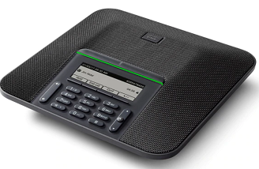

* The **Cisco IP Conference Phone 7832** would be {{ customer }} primary conference phones. The 7832 is an easy-to-use, easy-to-manage, high-quality endpoint with a contemporary design. It delivers 360-degree room coverage to address the needs of medium to large conference rooms (i.e., up to 800 square feet).

The Cisco IP Conference Phone 7832 comes standard with unique acoustics to deliver big sound in a small package. With support for wideband audio and full-duplex communications, the 7832 delivers high-quality, crystal-clear, business-grade audio conferencing. Your employees can collaborate more efficiently with others, and your business can get things done. The 7832 offers a sleek, modern design that fits in nicely with today’s more contemporary offices. It’s ideal for your small conference or huddle rooms, as well as for private office desks, such as those of the executives.

**Features of the 7832**

* 360-degree room coverage for spaces up to 172 square feet (16 square meters)
* Microphone pickup up to 7 feet (213 centimeters) from the endpoint
* Generous mute button to aid access from all sides of the endpoint
* Raised edge to ease handling and repositioning at the table or desk
* 3.4-inch (8.6-cm) backlit, monochrome, pixel-based display with an antiglare bezel to make viewing and interaction easier

{%p endif %}

{%p endif %}

**{%p if cuc %}**

**Cisco Unity Connection**

Iron Bow proposes the Cisco Unity Connection (CUC) for voicemail. Cisco Unity Connection is a robust unified messaging and voicemail solution that provides users with flexible message access options and IT with management simplicity. Unity Connection can be integrated with Microsoft Office 365 as well as older versions of Microsoft Exchange to enable synchronization of voice messages in Unity Connection and O365 mailboxes—also known as Single Inbox—is part of a standard UCM Cloud deployment.

The proposed Cisco Unity Connection features Cisco SpeechView, which converts voice messages to text and delivers the text version of the voice message to a user’s email inbox. This feature allows {{ customer }} users to read their voice messages and take immediate action. As part of the Cisco Unity Connection unified messaging solution, the original audio version of each voice message remains available to users anywhere and anytime. SpeechView also transcribes and sends voice messages within minutes of being left in a user’s voice mailbox, so users do not need to learn any commands or take special action to receive text versions of their voice messages. Unity Connection has fully customizable data retention policies that can be tailored to meet any specific data retention needs. This includes the capacity to maintain voicemails for 30 days.

Unity Connection will also be used to handle {{ customer }} Auto Attendants (AA). This will allow {{ customer }} to have a single point of management for all AAs and to use templates to deploy updates to AA menus. Each {{ customer }} can also have the ability to modify their locations AA as needed. Each store/AA/location will also have a general VM box as needed and up to 5 user options in the AA call flow.

{%p endif %}

{%p if imp %}

**Cisco IM and Presence**

Iron Bow will stand-up Cisco IM and Presence (IMP) for {{ customer }} as part of the UCM Cloud deployment. Cisco IM and Presence consists of many components that enhance the value of a Cisco Unified Communications system. The main presence component of the solution is the Cisco IM and Presence Service, which incorporates the Jabber Extensible Communications Platform and supports SIP/SIMPLE and Extensible Messaging and Presence Protocol (XMPP) for collecting information regarding a user's availability status and communications capabilities. The user's availability status indicates whether or not the user is actively using a particular communications device such as a phone. The user's communications capabilities indicate the types of communications that user is capable of using, such as video conferencing, web collaboration, instant messaging, or basic audio.

The aggregated user information captured by the Cisco IM and Presence Service enables Cisco Jabber, Cisco Unified Communications Manager applications, and third-party applications to increase user productivity. These applications help connect colleagues more efficiently by determining the most effective form of communication.

{%p endif %}

{%p if expressways %}

**Cisco Expressway**

Iron Bow proposes the Cisco Expressway/Mobile and Remote Access (MRA) solution to solve the need for circuits and voice gateways at each of the 387 {{ customer }} stores. Iron Bow will deploy Cisco Expressway Control and Expressway Edge in a clustered environment in the {{ customer }} Data centers. Any MRA solution requires Expressway and Unified CM, with MRA-compatible soft clients and/or fixed endpoints.

The solution can optionally include the IM and Presence Service and Unity Connection. Unified CM provides call control for both mobile and on-premises endpoints. Signaling traverses, the Expressway solution between the mobile endpoint and Unified CM. Media traverses the Expressway solution and is relayed between endpoints directly. All media is encrypted between the Expressway’s and the mobile endpoint.

{%p endif %}

{%p if cer %}

**Cisco Emergency Responder**

Iron Bow proposes Cisco Emergency Responder (CER) for as the Enhanced 911 (E911) solution which is a part of the core UCM Cloud proposal. CER enhances the existing emergency 911 functionality offered by the UCM Cloud, assuring that it will send emergency calls to the appropriate Public Safety Answering Point (PSAP) for the caller's location, and in turn the PSAP can identify the caller's location and return the call if necessary. In addition, CER automatically tracks and updates equipment moves and changes. Deploying this capability helps ensure more effective compliance with legal or regulatory obligations, reducing the risk of liability related to emergency calls as a result.

Coupled with UCM Cloud, CER surpasses traditional private branch exchange (PBX) capabilities by introducing user or phone moves and changes at no additional cost, as well as the dynamic tracking of user and phone locations for emergency 911 safety and security purposes.

{%p endif %}

{%p if on_premise %}

**On-Premise Implementation**: The proposed solution will utilize (4) four Cisco Expressway Control and Edge, (2) two Cisco Unified Border Element (CUBE) gateways and (1) one Cisco VG310 for analog connectivity at {{ customer }} HQ. The CUBE serves a critical role in linking networks and provides a seamless experience for voice and video users. CUBE is especially suited to facilitating:

●     PSTN interconnect using Internet service provider SIP trunks, which allow rapid service delivery and the possibility of capacity pooling across locations.

●     Migration from TDM to SIP public telephony trunk services. As Cisco Integrated Services Routers (ISR) allow the concurrent use of voice gateway and CUBE features, a phased trunk migration is possible without requiring changes to the enterprise call control platform.

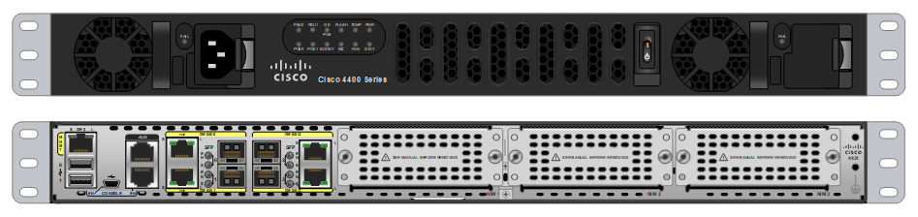

The UCM Cloud solution supports existing analog endpoints and plain old telephone service (POTS) connection through the use of the Cisco VG310 Analog Voice Gateways. These devices enable {{ customer }} to continue using traditional analog devices while taking advantage of the productivity afforded by IP infrastructure. This will used to support the {{ customer }} HQ analog faxing requirements.

The Cisco VG310 is offered in a 19-inch rack-mount chassis form with two 10/100/1000BASE-T Gigabit Ethernet ports, external compact flash memory and 24-analog Foreign Exchange Station (FXS) voice ports using one RJ-21 analog voice interface connector.

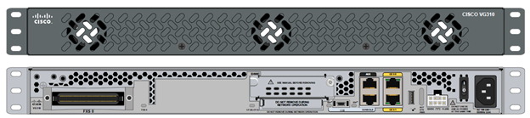

{%p endif %}

{%p if efax %}

**eFaxing**

To replace the analog fax machines at each of the remote {{ customer }} 378 stores and 8 regional offices, Iron Bow proposes {{ efax_partner }} IP Fax Server, a completely software-based IP fax server that virtualizes fax management, making it fast, easy, and safe to send and receive faxes at work. {{ efax_partner }} product delivers faxes directly to each user’s desk via e-mail, web, multifunction printers; in Cisco Jabber; and in mobility, on smartphones and tablets.

{% if efax_partner == “StoneFax” %}

Cisco has chosen {{ efax_partner }} as its official fax server solution worldwide, and, since February 2012, it is available for purchase directly from the Cisco Global Price List (GPL) in its Solutions+ program.

{% endif %}

{%p endif %}

{%p if call_recording %}

**Call Recording**

Iron Bow proposes the Imagicle Call Recording application for a centralized solution for call recording (audio recording) for Cisco UC platforms. It's easy to use, reliable, flexible and dedicated to any company that needs to record calls either for critical services with legal requirements, for operator training or just to keep track of important calls. It offers two recording modes: Always On, where every single call is automatically recorded with no user intervention, and On Demand, for only those conversations that need to be recorded. Imagicle Call Recording can be integrated with Cisco platforms in three ways, making it perfect for e-cloud hosted environments as well.

Imagicle Call Recording is a client/server application and an Imagicle Application Suite add-on. It can co-reside on the same physical/virtual server as Application Suite with which it shares the user database, with external source synch and authentication capabilities (Cisco UCM, LDAP, Active Directory), for ease of administration.  
Thanks to the modern recording technologies used (requires no sniffer or network apparatus to capture traffic), it can be used both on-premise and in e-Cloud hosted environments. Simple licensing based on the number of simultaneous recording channels, regardless of the number of telephones/agents you want to record.

{%p endif %}

## Core Datacenter UCM Cloud Build Tasks

At a high level, the implementation will include the following:

**Networking Infrastructure:** Cisco will install and provision UCM Cloud networking infrastructure. The following tasks will be performed at the Cisco datacenters:

* Provision and configure network for UCM Cloud
* Enable Virtual Route Forwarding (VRF) to Iron Bow
* Propagate VRF information to both Dallas/San Jose datacenters and UCM Cloud

{%p if ucm %}

**Unified Communications Manager (UCM):** Cisco will install and provision UCM Cloud Unified Communications Manager servers. The following tasks will be performed at the Cisco datacenters:

* Install and configure VMware ESXi
* Install Cisco Unified Communications Manager OVA templates
* Set sizing parameters from design meeting
* Configure IP addressing information
* Verify access to web management interface

{%p endif %}

{%p if cuc %}

**Unity Connection (CUC):** Cisco will install and provision UCM Cloud Unity Connection servers. The following tasks will be performed at the Cisco datacenters:

* Install and configure VMware ESXi
* Install Cisco Unity Connection OVA templates
* Set sizing parameters from design meeting
* Configure IP addressing information
* Verify access to web management interface

{%p endif %}

{%p if cer %}

**Emergency Responder (CER):** Cisco will install and provision UCM Cloud Emergency Responder. The following tasks will be performed at the Cisco datacenters:

* Install and configure VMware ESXi
* Install Cisco Emergency Responder OVA templates
* Configure CER Integration with CUCM

{%p endif %}

**{%p if not on_premise %}**

**Expressway – (IF IN CLOUD)**

Cisco will install and provision UCM Cloud Expressway C and Expressway E servers. The following tasks will be performed at the Cisco datacenters:

* Install and configure VMware ESXi
* Install Cisco Expressway OVA templates
* Set sizing parameters from design meeting
* Configure IP addressing information

{%p endif %}

## Core Datacenter UCM Cloud Configuration Tasks

{%p if ucm %}

**Unified Communications Manager (UCM):**

Iron Bow will configure UCM Cloud Unified Communications Manager servers. The following tasks will be performed:

* Configure standard telephone Partitions and Calling Search Spaces per the design documentation
* Configure PSTN Gateway connectivity.
* Configure Route Groups and Route Lists
* Configure Standard route patterns to support user outbound calling, for local, long-distance and international (if required)
* Configure 911 emergency access
* Configure up to twp (2) IP phone templates. Each phone will have a maximum of 2 line appearances unless otherwise stated
* Configure up to four (4) Phone Security Profiles based on number of phone models
* Configure IP Phones and End User associations
* Configure Hunt Groups, Pick Up Groups and Conference Now bridges
* Configure Voice Gateways Media Resources and respective Media Resource Groups and Lists
* Import Station Review document into Unified Communications Manager
* Configure Music on Hold with default music file
* Configure one software-based conference bridge and hardware-based conferencing resources.
* Configure emergency calling partitions and calling search spaces
* Configure emergency calling route patterns
* Integrate with Active Directory to support the Corporate Directory and User Database

{%p endif %}

{%p if cuc %}

**Unity Connection (CUC):** Iron Bow will configure UCM Cloud Unity Connection servers. The following tasks will be performed:

* Liaison with {{ customer }} IT staff to prepare the co-located customer-provided access to Exchange/O365 to synchronize messaging between Unity Connection and Exchange/O365
* Configure Unity connection to communicate with Unified Communications Manager
* Configure user mailboxes using default templates
* Configure {{ num_aa }} enterprise level auto-attendant tree with up to 5 selections
* Configure {{ num_ch }} Call Handlers for each store location to include the following:

Opening greeting, Open/Closed schedule, Holiday Schedule, Store voicemail box and option to press “0” for main number.

*Note: See Assumption 24*

{%p endif %}

{%p if imp %}

**IM and Presence (IMP)**

Iron Bow will configure UCM Cloud IM and Presence servers. The following tasks will be performed:

* Integrate IMP with CUCM
* Configure any Jabber profiles as needed

{%p endif %}

{%p if expressways %}

**{%p if on_premise %}**

**Expressway-C/E(On-Prem)**    
Iron Bow will install and provision Expressway-C and Expressway-E for MRA servers in the {{ customer }} Data Center. The following tasks will be performed at the {{ customer }} datacenters:

* Install Expressway-C/E OVA templates
* Set sizing parameters from design meeting
* Configure IP addressing information
* Configure MRA communication with Unified Communications Manager
* Coordinate with the security administrator to open required ports for MRA for traversal
* Customer responsible for all internal and external DNS configurations
* Customer responsible for all public and private server certificates
* Verify access to web management interface
* All {{ customer }} store phones will use Mobile Remote Access (MRA) to register to the CUCM for call control.
* {{ customer }} to insure minimum bandwidth of 384kbps for MRA phones at each {{ customer }} store.

*Note: See Assumption 5,*

{%p endif %}

**{%p if not on_premise %}**

**Expressway-C/E(Cloud)**    
Iron Bow will configure Expressway-C and Expressway-E for MRA servers in the {{ customer }} Data Center. The following tasks will be performed at the {{ customer }} datacenters:

* Install Expressway-C/E OVA templates
* Set sizing parameters from design meeting
* Configure IP addressing information
* Configure MRA communication with Unified Communications Manager
* Coordinate with the security administrator to open required ports for MRA for traversal
* Customer responsible for all internal and external DNS configurations
* Customer responsible for all public and private server certificates
* Verify access to web management interface
* All {{ customer }} store phones will use Mobile Remote Access (MRA) to register to the CUCM for call control.
* {{ customer }} to insure minimum bandwidth of 384kbps for MRA phones at each {{ customer }} store.

*Note: See Assumption 5,*

{%p endif %}

{%p endif %}

{%p if cer %}

**Cisco Emergency Responder (CER):** The following tasks will be performed: by Iron Bow to configure CER for 911 nonfictions.

* Verify access to web management interface
* Configure licensing and ensure proper counts
* Configure Emergency Call Routing for Emergency Location Identification Numbers (ELIN) and Emergency Response Locations (ERL) and assign them to proper store locations per subnet or manual entry
* Configure Emergency Call Routing for dynamic association of the ELIN to the calling phone for callback purposes
* Configure emergency notifications per ELIN/ERL
* Configure 1 ELIN/ERL per {{ customer }} store location. Additional ELIN/ERL for regional and Headquarters locations

*See Assumption 11 and 12*

{%p endif %}

{%p if efax %}

**{{ efax_partner }}IP Faxing Server**: Iron Bow Engineers will install and configure the {{ efax_partner }} IP Faxing server on premise. The following tasks will be performed:

* Install {{ efax_partner }} servers
* Configure primary server
* Configure secondary server
* Configure licensing and ensure proper counts
* Integrate {{ efax_partner }} with UCM Cloud for call routing
* Ensure call routing for local, long distance, and international faxing outbound
* Configure up to {{ fax_endpoints }} DID-number faxing endpoints
* Configure email integration for up to {{ fax_email_integrations }} destinations

*Note: See Assumption 3 and 4*

{%p endif %}

{%p if call_recording %}

**Imagicle Call Recording**: The following tasks will be performed by Iron Bow to implement Imagicle Call recording.

* Install Imagicle Call Recording servers
* Configure primary server
* Configure secondary server
* Configure licensing and ensure proper counts
* Integrate Call Recording with UCM Cloud for on demand recording
* Configure up to {{ recording_channels }} channels for recording

*Note: See Assumption 3*

{%p endif %}

{%p if webex_meetings %}

**WebEx Meetings**:Iron Bow will work with {{ customer }} to complete the WebEx provisioning documentation:

* Provision WebEx instance
* Creation of users {{ webex_users }}
* Verify access to web management interface

*Note: See Assumption 30 and 31*

{%p endif %}

## Voice Gateway System Configuration

{%p if cube %}

**Cisco Unified Boarder Element (CUBE):** Iron Bow will configure the CUBE voice gateways for use with UCM Cloud. The following tasks will be performed at the customer site:

* Configure SIP trunk towards the telephone provider
* Configure trunk to legacy PBX’s (if necessary)
* Integrate gateway with UCM Cloud
* Configure SRST for {{ srst_devices }} devices
* Verify data network connectivity
* Add router licenses to {{ customer }} Cisco Smart Account ensure routers use proper licenses

*Note: See Assumption 10*

{%p endif %}

{%p if analog_vg %}

**Analog Gateway:** Iron Bow Engineers will configure a single Voice Gateway to service the 12 analog lines coming into the building. The following tasks will be performed at the customer site:

* Install and configure VG310
* Integrate gateway with UCM Cloud
* Test and confirm analog faxing

{%p endif %}